Power Interruption events and managing Reliability.

The information below is a summary of the work of two separate CIGRE global working groups which considered the area of Reliability in uncertain environments and how a system operator may plan to manage power interruption events.

Whilst some of this information is becoming a little dated, the messages and themes are still relevant today.

Working Group C1.2 “Maintenance of Acceptable Reliability in an Uncertain Environment”.

In Technical Brochure 344, Working Group C1.2 studied thirteen major unreliability events spanning a period of eight years.

- New Zealand, Auckland 20th February 1998: Consecutive cable failures led to the black out of the Auckland CBD for 7 weeks.

- Algeria, 3rd February 2003: Loss of 2 generators when there was inadequate spinning reserve initiated this blackout.

- Iran, 31st March 2003: explosion of an underrated circuit breaker coupled with inadequate protection led to this event.

- USA, August 14th 2003: while this event was initiated by an overloaded line sagging into trees, lack of communication between System Operators due to the failure of a SCADA system was a major contributor to the extensive blackout across north east America.

- Finland, Helsinki 23rd August 2003: This event was triggered by a human error coupled with inadequate protection.

- England, London 28th August 2003: Protection maloperation led to loss of supply to 410,000 customers and major disruption to the underground railway services

- Sweden and East Denmark, 23rd September 2003: Total voltage collapse occurred when a large nuclear unit was lost at the same time as other major infrastructure was out for service.

- Italy, 28th September 2003: While triggered by a tree flashover, delays in carrying out measures to reduce overloading led to a massive blackout across Italy.

- Libya, 8th November 2003: Lack of circuit breaker fail protection led to consecutive tripping of ten 220kV lines

- Singapore, 29 June 2004: Gas and diesel fuel issues led to loss of supply to 300,000 customers

- Greece, 12th July 2004: Inadequate load shedding following loss of generators on a particularly hot day, led to this blackout

- Australia, 13th August 2004: Major load shedding occurred across several states when six generators tripped. However this allowed the system to rebalance and avoided a major blackout

- Europe - UCTE, 4th November 2006: Supply to 15 million customers was lost due to insecure operating conditions and inadequate coordination between system operators leading to cascade tripping of transmission lines and the subsequent separation into three large islands.

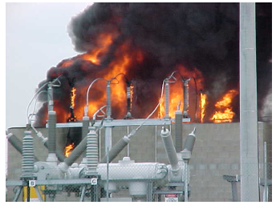

Three of the largest incidents in Europe and North America affected between 50 and 60 million people and resulted in disconnection of between 20 and 70 thousand megawatts of load. A regional incident in the south of Sweden and Denmark affected 4 million people and 6,500 MW of load was lost. Outside these large interconnections, incidents in Algeria and Iran respectively affected 98% and 50% (22 million) of the population where 5,200 MW and 7,000 MW of load were lost. Two major capital city incidents resulted in the loss of supply to 800,000 people in Helsinki and 410,000 customers in London, however many more people in London were affected due to the loss of supply to underground and railway transport services.

There is great industry interest in major unreliability events. Of the gravest concern are those that occur in major population centers or are spread over a vast geographical area, as they can adversely affect millions of people. The importance of supply to large urban centers, particularly to their central business districts, led to a decision to review planning standards in cities. Analysis of the above and comparison with real events identified critical contributing factors and a number of lead indicators of susceptibility of a particular power system to major unreliability events.

Economic pressures, impaired communication channels and system limitations were identified as the most common contributing factors. Others include social, economic, planning and operational, leading to a conclusion that underlying causes may originate in the governing macro-economic rules and regulations, which could be compounded by subsequent planning decisions and operational events. These include:

• A change in the function of system interconnection from one of mutual assistance at times of high stress on individual systems to one of facilitating large electrical energy trades across wide areas.
• The importance of understanding the system's limitations and the risks associated with increased loading.
• The need to pay more attention to the importance of identifying and respecting system security limits.
• The importance of operating the system securely within technical limits in the face of demands for increased capacity.
• The importance of defence plans to prevent widespread blackouts and facilitate rapid restoration; the importance of maintaining the defence plans and ensuring the integrity of the defensive measures (for example, in a number of cases automatic load-shedding did not perform as expected).
• The lack of control by TSO’s over generation output (changes of schedules, ability to start/stop the units).
• The fact that generators connected to the distribution system did not have the same fault ride through capabilities as those connected to the transmission system and they disconnected before the last stage of the under frequency load shedding protection was initiated.
• It is important to have commissioning and testing procedures that minimize the risk of protection maloperation. A number of incidents were caused by protection problems that were present but only triggered when a particular set of circumstances occurred (London, Helsinki).

The Brochure concludes with a list of possible planning recommendations and approaches to avoid or mitigate future major unreliability events.

======================================================================

Working Group C1.17, “Planning to Manage Power Interruption Events”.

In Technical Brochure 433, Working Group C1.17 draws on the findings of Working Group C1.2 and other related studies and focuses on measures to contain the extent of the impact of a major power interruption.

The way a power system has to be operated is changing significantly and poses new challenges for the transmission system operators, who are responsible for overall system security, and for planners who are responsible for providing operators with the facilities they need. A significant driver of this change is the liberalisation of electricity markets and large increases in wind and PV generation that have caused unpredictable power flows.

In order to meet the demands of electricity markets and environmental constraints, networks are increasingly planned and operated to their technical limits. Super grids are formed in order to reap the economic and security benefits of larger grids. Consequently, the impact of network failure is likely to become more widespread and the need to optimally manage ‘major unreliability events’ is becoming more important.

When failure occurs it should take place on a controlled basis. This requires planners and system operators to develop and implement suitable strategies for managing the failure path. Planners in particular need to deliver the investments needed to achieve this. This Working Group deals with the identification and justification of such investments.

The reduction of the initial extent of interruption of supply of power is the
purpose of defence measures and the broad classes of these have been described in the Brochure. Another dimension of impact is the duration of an interruption. If the initial interruption is, to some extent, controlled, the duration can be reduced, particularly by the use of restoration plans.

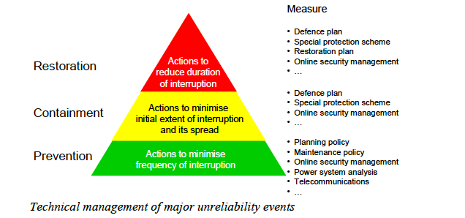

A survey of a number of countries determined that it is particularly difficult to justify substantial investment for the management of major unreliability events particularly as these events are generally quite rare. However, the Brochure does note that a regulator’s agreement to the recovery of the costs of a measure for containment of power interruptions is most likely to be gained

- Soon after a major interruption;
- When the transmission system is identified as a ‘critical infrastructure’ vulnerable to terrorist attack;
- When stakeholders are reassured (through provision of suitable documentation) that all other reasonable measures are already being taken.

