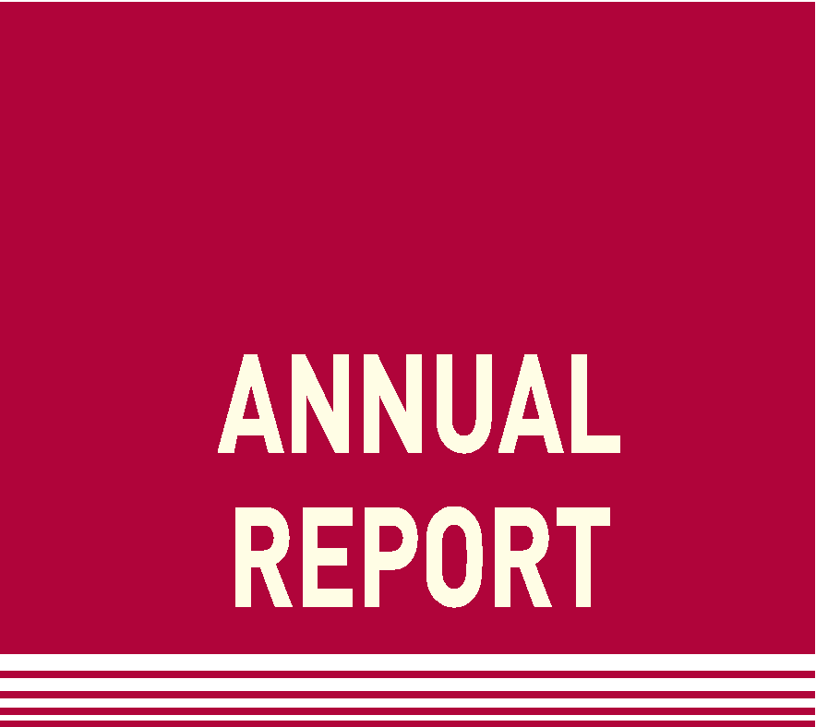**2017 Substations**

**By Terry Krieg, Chairman SC B3**

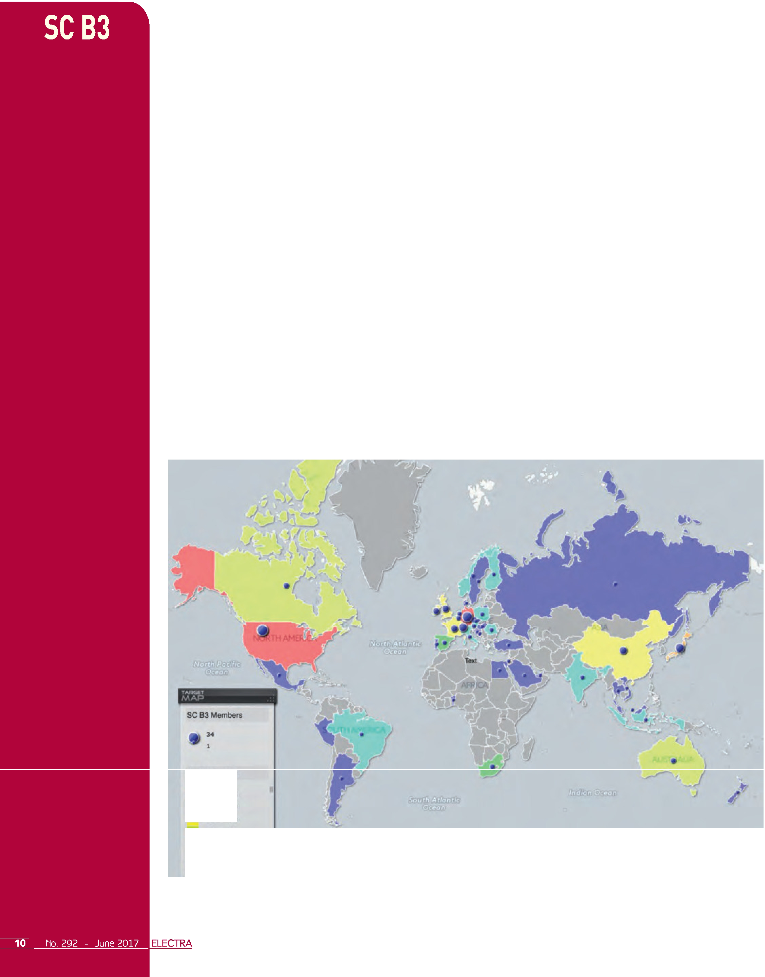

Transmission and Distribution substations continue to play a central role within electricity networks in providing safe and reliable energy to consumers.

The scope of work for Study Committee B3 (SC B3) includes the design, construction, maintenance and ongoing management of substations and electrical installations of power stations but excludes generators. We aim to serve a broad range of target groups in the power industry with our focus on not just the technical,but also the economic, environmental and social aspects of substations.

Major objectives for our committee include supporting asset owners to achieve increased levels of reliability and availability, more cost-effective engineering solutions, effective management of environmental impact, efficient asset management and to achieve this by the adoption of appropriate technological advances in equipment, systems and organisations.

In line with CIGRE, SC B3 aims to facilitate and promote the progress of engineering and the international exchange of information and knowledge in the field of substations. We aim to add value to this information and knowledge by synthesizing state-of-the-art practices developing recommendations and providing best practice.

We value the support from our experts from across the globe in 16 different working groups. At the end of 2016 our working groups included 278 individual experts from 38 countries representing the diversity of CIGRE membership and expertise across the globe.

**SCB3Exports**

•... **2'**

**25** • **34**

...

•• .

••..

### •

• '**l** •

'

Figure l - SC B3 Members and Experts Global Diversity

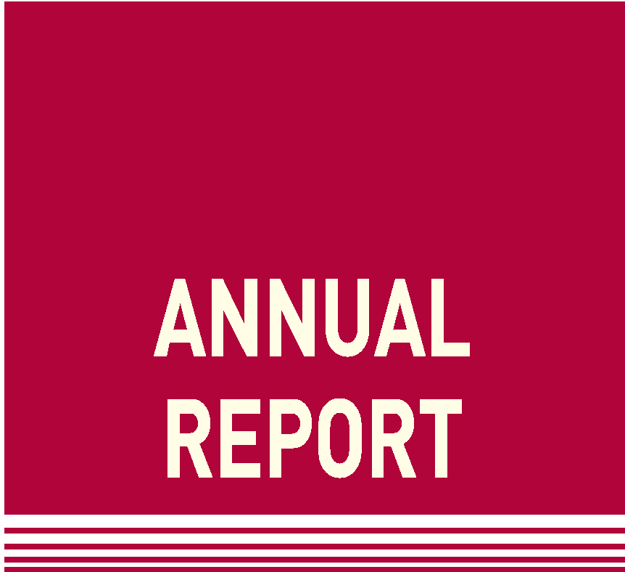In 2016, we adopted a new way of sharing information and managing our work with the new collaborative platform named the Knowledge Management System (KMS ). This has proved to be highly successful and has improved the way we manage and share information.

## Strategy and Direction

The Study Committee strategy and direction is continuously reviewed to ensure it is meeting the needs of our stakeholders. Our current strategic plan covers the period to the end of 2018. The long term strategic directions are shown in the graphic below (Figure 2):

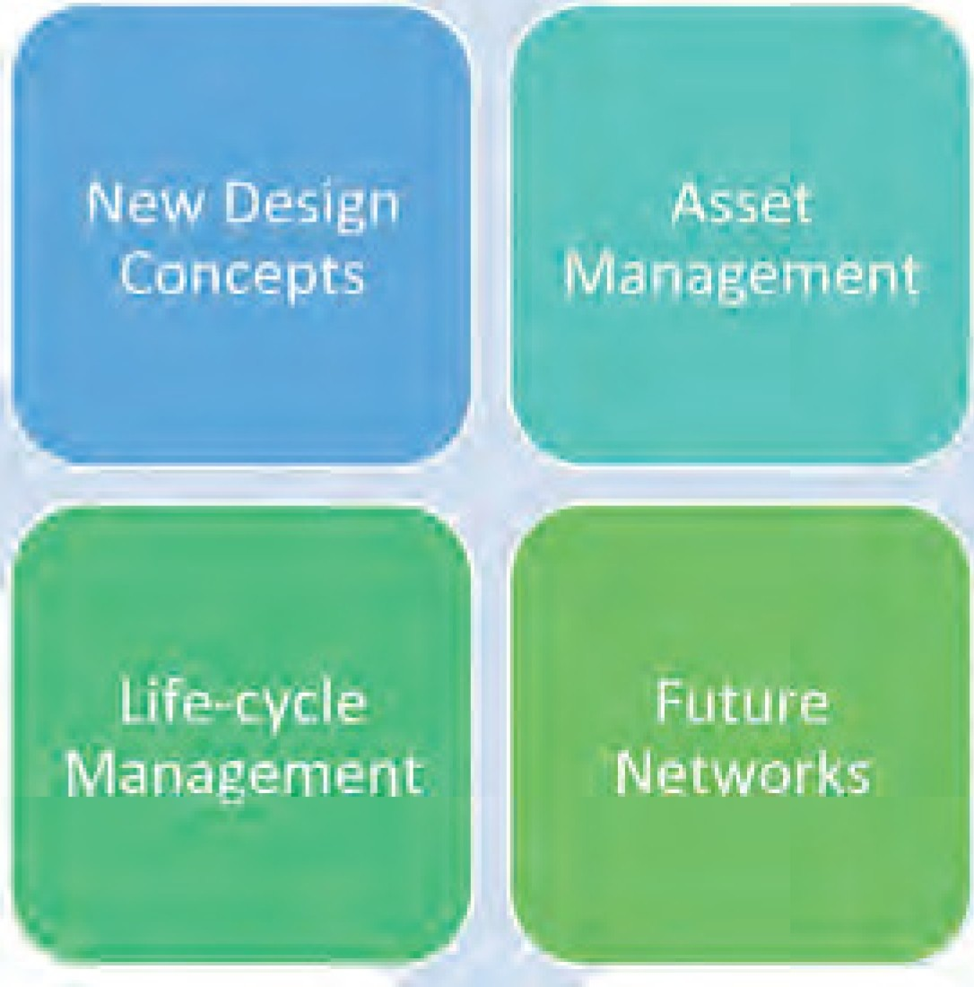

Figure 2 - Long-Term strategic directions for SC B3

The strategic directions for the study committee include a focus on continuously improving the way we communicate with the wider community using both traditional and new avenues of communication and global engagement. These new communication methods include the use of social media (Linkedln, Twitter), particularly to assist in engaging with younger members of the engineering community.

We have also increased our focus on safety and every meeting now includes a discussion and sharing of experiences aimed to assist in improving safety in substations.

## Workstreams

Our 16 current working groups are arranged in 4 key workstreams to assist in manging the flow of work:

1. Substation Concepts and Developments
2. Gas Insulated Substations and Lines
3. Air Insulated Substations
4. Substation Management

These workstreams interact and cooperate with our global experts to achieve our objectives and are represented graphically below.

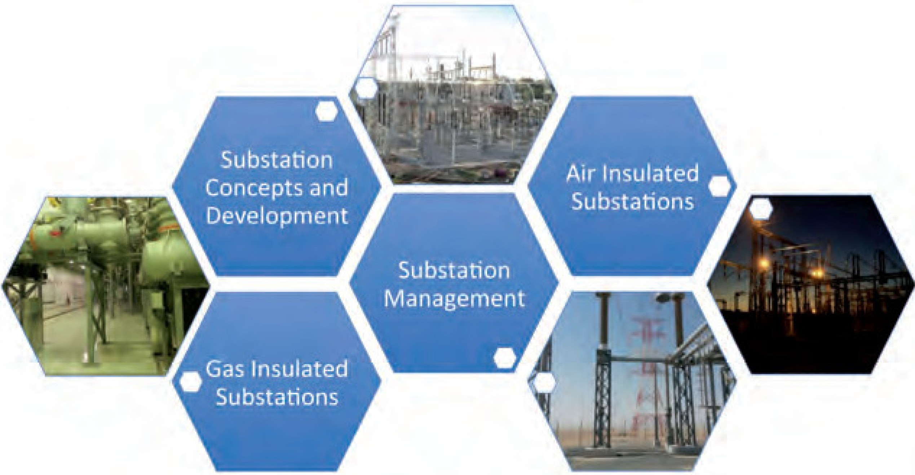

Figure 3 - SC B3 Workstreams

# 2017

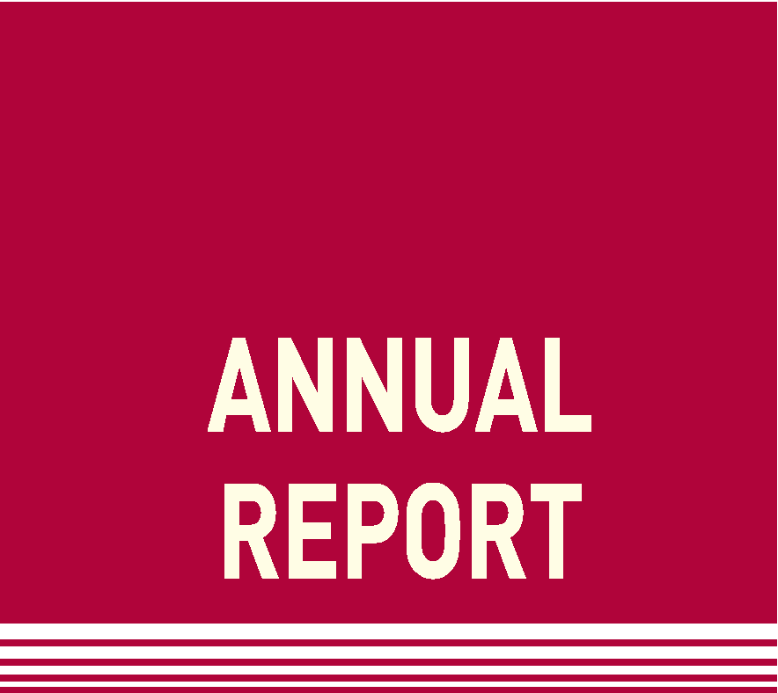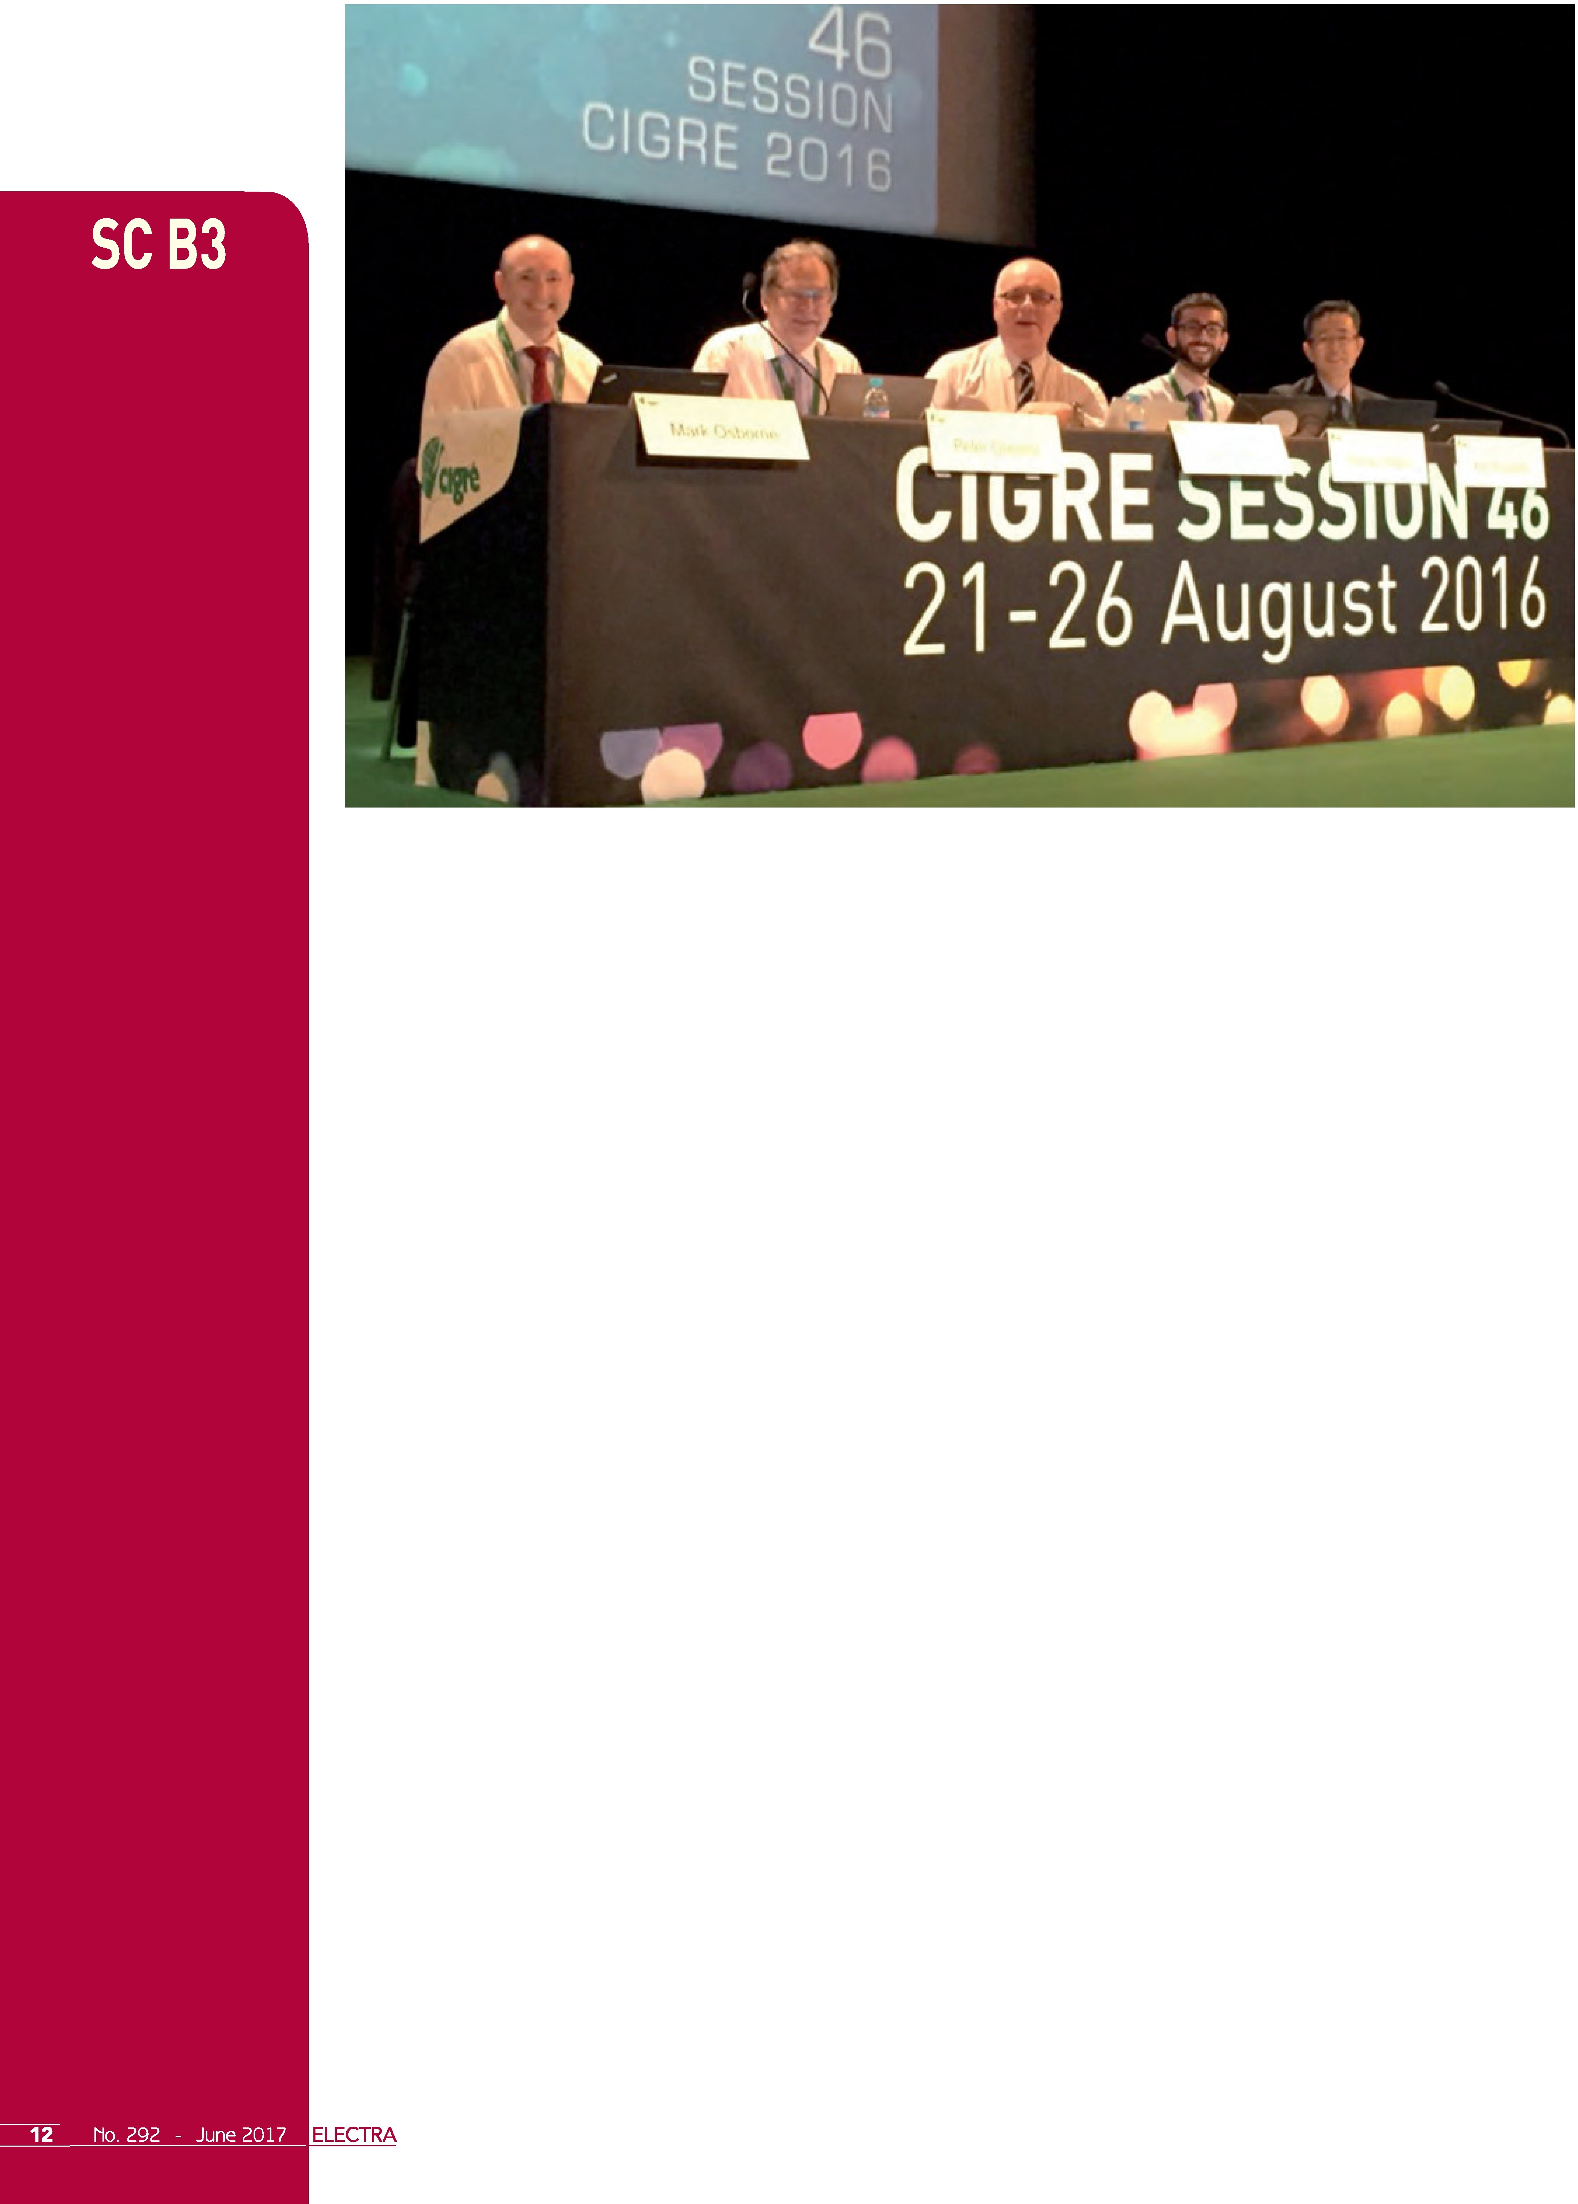

**2017**

Figure 4 - The 2016 Team for B3 Group Discussion Meeting (Mark Osborne, Peter Glaubitz, Terry Krieg, Romain Migne, Koji Kawakita )

#### Preferential Subjects

Like all other Study Committees, preferential subjects are adopted bi-annually and represent the shorter-term direction for the work of the Study Committee. The 2018 preferential subjects (adopted in 2016) demonstrate our commitment to continue to assist asset owners and operators to adapt substations to meet the needs for networks of the future but also to meet the on-going challenge in managing substations throughout their life cycle, meeting community expectations for Health and Safety and the Environment. This year we introduced new directions in training and in the aesthetics of substations . The 2018 preferential subjects are:

**Preferential Subject** I - **Advances in substation technology and design**

* + GIS and GIL developments including HVDC;
  + Adapting substations to meet emerging power system requirements, optimised availability and including modular, fast deployment substations and live working;
  + Changing roles and opportunities for substations including challenges for MV and integration of storage systems.

**Preferential Subject 2** - **Evolution in substation management**

* + Advanced technologies for substation management, new information technologies, robotics and the application of 3D techniques;
  + Risk quantification and optimised decision-making, substation economics, maintenance management and life-cycle management;
  + Substation asset performance, residual life, health and condition metrics;
  + Operations and maintenance of offshore substations.

**Preferential Subject 3** - **Health, Safety, Environmental and Quality Assurance considerations in substations**

* + Customer and stakeholder interaction to reduce substation impact including aesthetics noise and fire management;
  + Design for safety, eco-design/re cycling and environmentally friendly product development;
  + Physical and cyber-security considerations for substations;
  + Managing the implementation of health, safety and environmental requirements for substations, including training.

SC B3 aims to ensure that its long term and short term strategic objectives reflect the changing needs of the industry and the customers that it serves.

#### Events

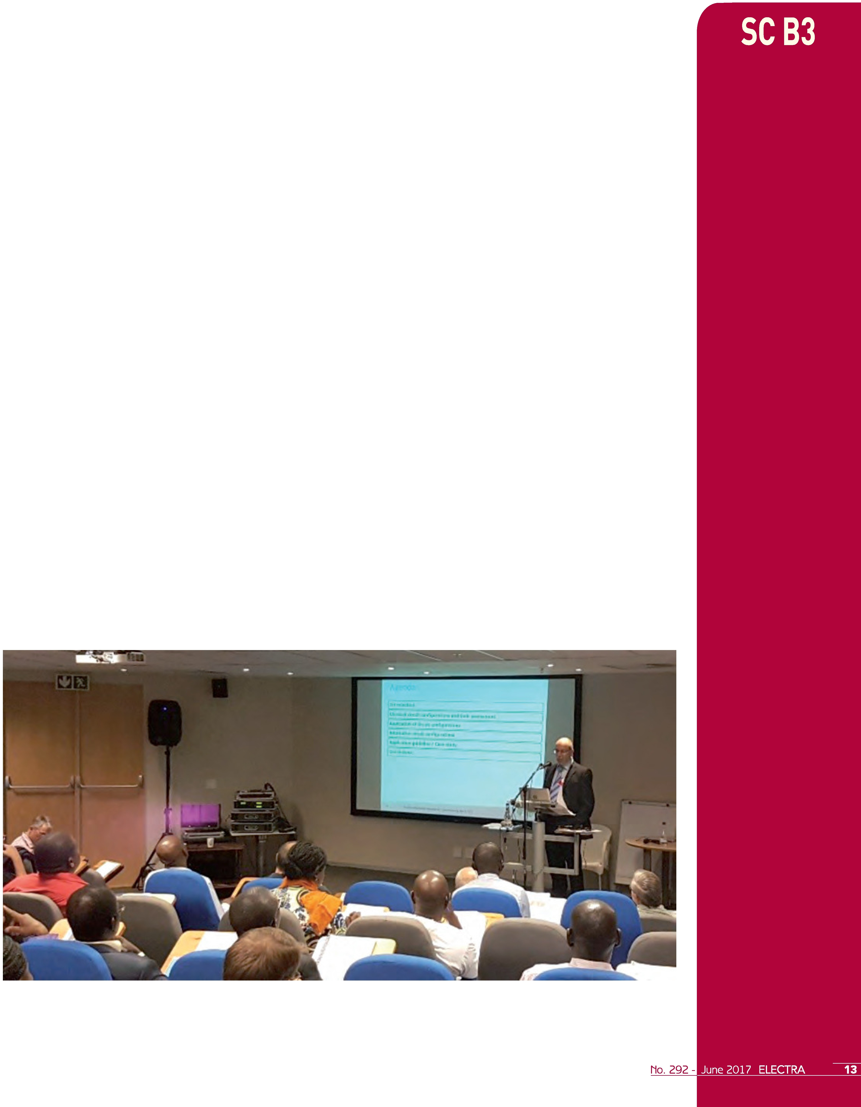Study Committee B3 held a very successful meeting with record attendances at the group discussion and poster sessions during the 46th Paris session in August 2016. Aiming to enhance the meeting and maximise the contributions of attendees, the group discussion session included the use of flash code technologies and online chat with the KMS system (72 posts during the meeting) to enable rapid access to relevant information and as a service for delegates. The week of Paris Session 46 activity for Substations included the following:

* **Study Committee Meeting** - a very successful meeting at which we welcomed 11 new Study Committee members (including 5 new member countries) with a record total of 40 national representatives (24 regular and 16 observers);
* **Group Discussion Meeting** - this included 38 papers, 64 contributors, 604 attendees from 62 countries;
* **Poster Session** - 34 Posters, record attendance of 551 delegates over two sessions;
* **Working Groups** - 10 Working Groups met during the 46th Paris session;
* **Tutorials** - 2 Tutorials were held by SC B3 experts.

Study Committee B3 is committed to addressing the needs of our members and stakeholders and satisfaction surveys were collected during the session to ensure that we are meeting the needs of all delegates.

Other key events with SC B3 involvement in 2016 included:

* Elecrama-2016, Bangalore, India, 15 - 16 February 2016
* 4th Conference on Applied Robotics for the Power Industry (CARPI-2016), Jinan City, China, 11 - 13 October 2016
* Colloquium "Building Smarter Substations", Mexico City, 14- 16 November 2016
* Workspot VIII, 20 - 23 November 2016, Recife, Brazil

SC B3 events in 2017 include:

* Workshop on "Low Cost Substations & Lines" Johannesburg (South Africa) 13-17 March 2017
* Symposium: "Experiencing the Future Power System. .. TODAY", Dublin (Ireland) 29 May- 2 June 2017
* Annual Study Committee meeting and Colloquium: "Challenges and Trends to the Next Years", Recife (Brazil) 18-20 September 2017

The attendance and participation in the Low-Cost Substations and Lines Workshop in Johannesburg was particularly pleasing with good participation from many African countries. This workshop was arranged by WG B3.43, in conjunction with the World Bank to identify ways to deliver low cost infrastructure to address the needs of the 1.2 billion people without access to electricity world-wide.

# 2017

Figure 5 - Colm Twomey, SC B3 Representative for Ireland delivered a Tutorial on Circuit Design Optimisation at the Johannesburg Workshop

13-17 March 2017

# 2017

There were man y other events in 2016 that included SC B3 involvement and we continue to interact with the global community, sharing knowledge and best practices.

#### Working Groups

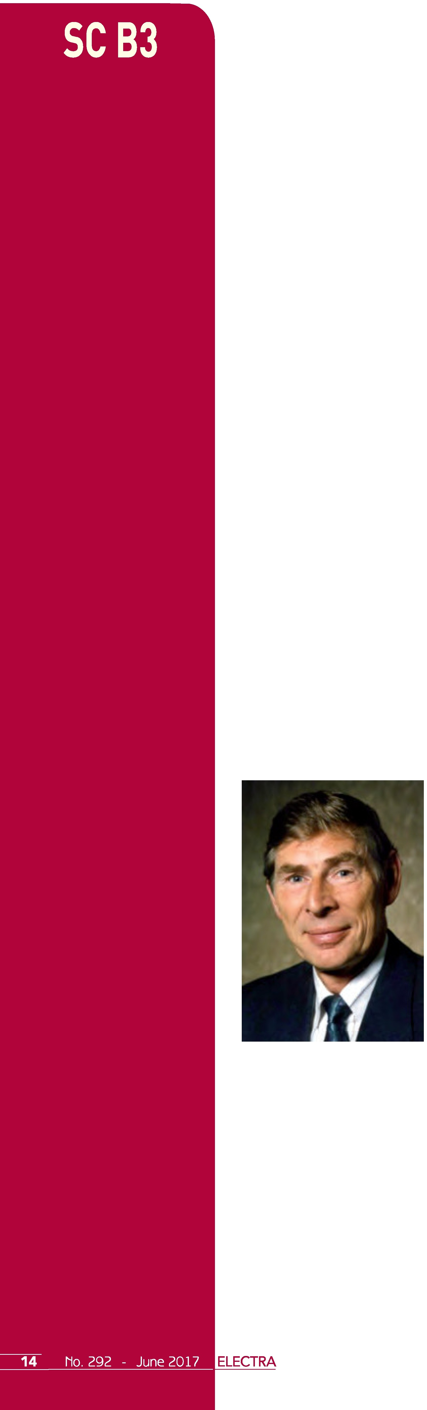Working Groups have been described as the "engine room" of CIGRE work. During 2016, a number of Working Groups completed their work and new ones were commenced . The total number of active Working Groups at the end of 2016 was 16. New Working Groups in 2016/2017 include:

* + **B3.45** - Application of non-SF6 gases or mixtures in medium voltage and high voltage gas-insulated switchgear (approved 29/06/2016)
  + **B3.46** - Guidelines for Safe Working in Substations (approved 04/09/2016)
  + **B3.47** - Application of Robotics in Substations (approved O1/11/2016)
  + **B3.48** - Asset health indices for equipment in existing Substations (approved 30/11/2016)

#### Publications

Recent publications for Study Committee B3 include:

* + **TB 660** - Saving through optimised maintenance in air insulated substations
  + **TB 674** - Benefits of PD diagnosis on GIS condition assessment
  + **TB 686** - Internal Arc effects in Medium Voltage Switchgear (l-52kV)

Work continued in 2016 on the Substation green book, the first of two SC B3 Green Book projects. These works will be used to encapsulate and present the consolidated information available in the CIGRE body of work in relation to Substations and to identify new study areas for future direction of B3 activities. This first Green Book will be published in late 2017. The second green book on SF6 was launched in 2016 for publication in 2019.

A key focus of B3 activities is considering how to provide opportunities for young member participation in connection with CIGRE "Young Members Network" as well as to increase the involvement of Women experts.

#### Awards

The Customer Advisory Group Chairman, Mr Mick Mackey (Ireland) was awarded the SC B3 Technical Committee award for 2016. This award recognises the many contributions that Mick has made to the work of CIGRE and the Study Committee over a number of years under several positions.

#### In Memoriam - Adriaan ZOMERS

Study Committee members were saddened to hear that SC B3 comm unity member and friend, Adriaan ZOMERS passed away on 5th of January 2017. For the last two decades, he was energy adviser for the Dutch Government and after the reorganization of CIGRE's technical activities in 2005 he was invited to also join the new SC C6 on Distribution and Dispersed Generation as an expert member to address the electrification of rural and remote areas. There he has been secretary or member of specific working groups, members of panels and keynote speaker as well as chairman of the International Advisory Group on Rural Electrification . It will not be easy to recover from this very sad bereavement for CIGRE in general and for Study Committee B3 in particular.

#### Conclusions

This year, Study Committee B3 continues its work in addressing the needs of Substation designers, users, owners, operators and managers around the globe. We are extremely grateful for the on-going support of members and members' organisations and our Substation experts as we continue towards the development of our part in the Network of th e Future. •