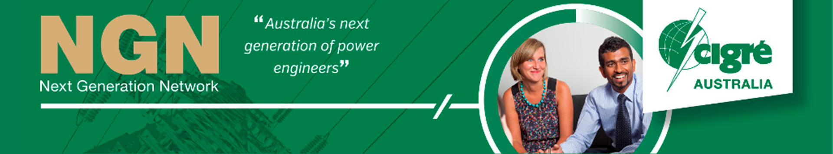

NGN Scholarhsip Paris Session 2016 Report

Emma Rogers

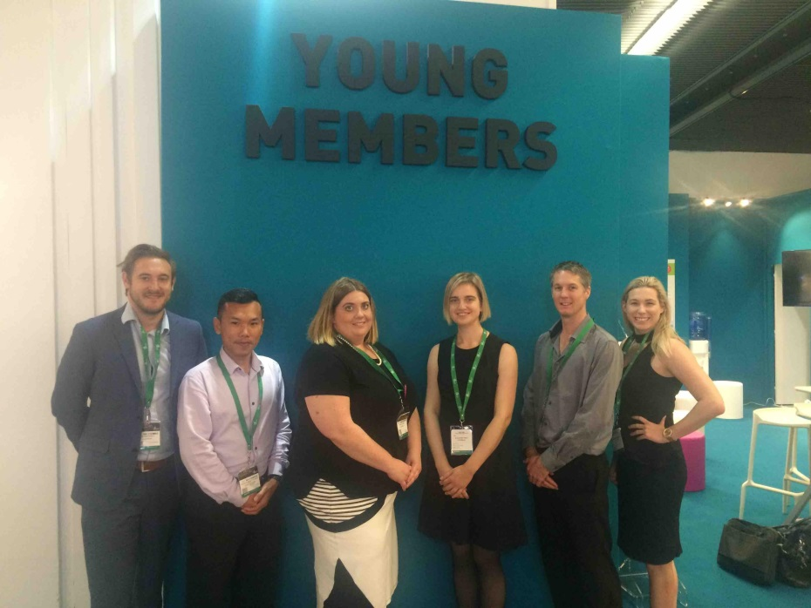Key Learnings

29 October 2016

# CIgre

Throughout the sessions I gained a better understanding of the Cigré structure, its goals and how the committees and working groups function to deliver tutorials, brochures and white books. I was overwhelmed with the homogenous interaction of the Cigré international community working towards achieving common goals. The amount of knowledge that the collective community has is astounding and I think it is taken for granted that it is an achievement that not many other industries have been able to achieve.

It was extremely humbling to be able to discuss technical issues with some of the most prominent engineers in their field and understand that all networks have similar challenges and that working together to solve these issues is the most efficient method that delivers better results. As a result of the sessions I have broadened my areas of interest to include B5, B4, C1, C2, C6. I have also established connections across the Australian Cigré community.

The discussion about where the distribution network sits within Cigré was very topical and interesting particularly with my role in a distribution utility. At the moment, while some SCs cover both transmission and distribution equipment, a majority of the distribution sits separately in C6. However with the distribution network now facing challenges that have been historically only of concern at the transmission level, due to bi-directional power flows the distribution network is now having a bigger impact on the stability of national grids.

The technical exhibition provided an unparalleled opportunity to look at new equipment and technologies while being able to talk directly with developers. I was able to establish connections with new and existing suppliers and discuss equipment on the market that can solve some challenges with existing equipment. In particular I was able to identify secondary systems equipment that could result in a safety improvement in my organization if implemented.

# NGN Activites

## Young Members Stand

While on the young members stand I was able to network with other young members from other national committees. Key outcomes from these discussions include:

* In conjunction with the United States representative we identified that there is an opportunity for us to broaden the reach of our webinar series to international NGN members. This would allow us to share and expand the content available to NGN members worldwide. If there was a long term strategy amongst all national NGN groups then challenges such as time zone differences across the same country can be minimized by providing other opportunities.
* The Russian Federation NGN members were very proud of their power engineering competition, where they release a book of technical problems that need to be solved, and young members submit their fully worked solutions for assessment.. Following the awarding of prizes, a solution book is released for all those that enter. Some of the benefits of this competition are increasing the basic technical knowledge of their members and increasing engagement levels from universities. This may be something that the Australian NGN may be after leverage off to increase participation in universities, and those early in their careers for example those participating in graduate programs.
* As a collective group we were able to influence National committees that don’t currently have a young member groups and were able to pass on strategies to establish a group through the best practice guide to engaging young members.
* I was surprised by the lack of representation of a French young member group, particularly as the Sessions were being held in Paris.

## Substation Site visit

I attended the substation site visit of La Muette 220kV/20kV substation. Some of the aspects that I found valuable were:

* Understanding their site contraints (vertical layout ) – similar to substations in Brisbane CBD. There was also very definite future expansion capability, with dedicated bays installed at the outset.
* Focus on fire protection, dedicated water storage and collection tanks, use of misting systems
* Use of isolators rather than circuit breakers in inner city substations. Protection systems utilize intertripping to the supply substations in the ring. Ring configuration allows them to withstand and single outage by reconfiguration.
* Noise attenuation strategies. Baffling and noise proofing to minimize the impact on adjacent residential customers.
* Distribution equipment was very similar to Energex equipment, including their impedance earthing method.
* I was surprised by the age of the protection relays in service in the substation

## Young Engineer Forum

During the young engineer forum it was interesting to hear the structure of other NGN groups. Particularly, other groups were envious of the support the ANC has by providing free membership until age 35. Other groups have a set membership term until they are no longer a young member and most have a small fee associated with membership.

There was valuable discussion between all the young members regarding how to make sure that we are integrated into Cigré and not operating as a different group all together and how to approach conveners of working groups to be accepted as an NGN representative.

# Women In Engineering forum

It was extremely good to see high level support for the Women in Engineering forum from the Technical Committee Chairman – Mark Waldron and from all the national committees.

I found the forum itself was a little confronting and may not have pushed the right agenda in that I don’t think the opportunity was seized to identify action strategies that can be implemented to improve the diversity of Cigré, instead it focused on the current situation and why diversity is important and the gender stereotypes. This however, provided myself and Alexandra with the drive to develop a strategy for ANC.

One of the other aspects of diversity that was highlighted in one of the presentations was that diversity is not just gender diversity. There are other minority groups that need support and representation in addition to women, in particular those that are underprivileged. In the Australian context, this may relate to our indigenous population, or refugees now settled in Australia, and the inclusion of these groups are equally as important within Cigré.

# Poster PresentationS

I had the privilege of being able to present a poster in the B5 session on, ‘Disconnecting overvoltage conditions at multi-transformer sites using reactive power flow methods’. I was able to discuss my application of voltage protection with members of the B5 community and identify further improvements. I was also able to share this challenge with a tapchanger manufacturer who was looking for improvements in their control equipment.

I also provided support for the C1 poster session by providing guided tours for the session as a trial structure for the poster sessions.

# Group Discussion Meetings

The group discussions were unique in their structure, and I liked how these progressed the content of the papers and provided the ability for national committees to make contributions on those topics.

The B5 session focused on PACS optimization (PS1) and the coordination of generator protection (PS2). I gained a better understanding of the challenges facing interoperability within the 61850 process bus space. Some of the challenges facing the rapid changes within the transmission and distribution networks means that there is a greater number of network configurations that affect fault levels and impact protection schemes. The discussion focusing on how to improve these processes were topical and identified that there are still significant efficiencies that can be achieved through the standardization of setting tools and the storage of information.

The C6 session had a broad range of contributions on numerous preferential subjects that focused on embedded generation in distribution networks and how they can be managed in the absence of accurate data. I was able to identify many of the problems that Energex is facing in to topics and I have been able to take some of the ideas suggested to manage these conditions and investigate if these are possible in the Energex network.

# ENglish LANGUAGE in an IntERNATIONAL environment

One of the challenges that Cigré faces that I saw throughout the conference is use of the English language in an intentional context.

For example during the C1 poster presentations I was engaged in a group discussion with the convener and other members from WG-C1.27 regarding the proposed changes to the definition of security and adequacy in the Cigré Glossary of Terms Used in the Electricity Supply Industry. The trigger for exploring a change is the bi-directional power flow capability that customers are expecting. The challenge that the working group is facing is that some countries prefer more detailed and lengthy definitions whereas others prefer simple definitions relying on the true definitions of words. This was a very valuable experience to be part of. These discussions have left me with an increased awareness and to take a more considered approach and to avoid the use of colloquialisms.

The other area in which this was also apparent was during the B5 sessions where numerous contributions were made highlighting that there are timing issues being caused by differences in manufactures interoperability of merging unit equipment used in process bus applications. This is having an effect on protection schemes that rely on messaging to other equipment in particular the stability of feeder differential schemes. This highlights that manufacturers are implementing the IEC61850 standard differently and is possibly caused by different interpretations of the standard. Again this highlighted the importance of clarity in standards and Cigré Brochures, tutorials and white books to ensure that we are working together towards the end goal.