# Introduction

I, Matthew Ridgley from Ergon Energy had the honour of representing the Australian Next Generation Network at the 2016 Paris Sessions as a result of winning the CIGRE ANC Scholarship. This was a very exciting opportunity for me to expand my knowledge on both the electricity industry as a whole as well as CIGRE as an organisation. I am very grateful to have been selected for this opportunity.

# CIGRE Contributions while in Paris

I had the chance to contribute at a number of events while at the Sessions. These included:

* Attending the WG B3.42 Reliability analysis and Design Guidelines for LV AC/DC Auxiliary Systems of which I am a corresponding member of. This gave me the opportunity to meet a number of the members of this working group face to face and get a better understanding of the working group and its work.
* I was able to provide a presentation at the B3 Substations General Meeting in one of the two slots allocated to young members. I presented on Ergon’s pre-fabricated, modular and fast deployment substation solutions as per preferential subject B3 PS2.
* I was able to participate in the B3 Poster Sessions with my presentation about Ergon’s solutions. I had interest from a number of parties, some that had done similar things and some that were looking into them.
* I attended the NGN / Young Members Forum where young members could explain what they’re regional groups were doing to promote CIGRE to the younger audiences and try get interested parties involved in CIGRE activities. It was interesting to see the many different approaches being undertaken with the same level of passion. I would have to say, I think the current Australian NGN Committee model is a very strong model.

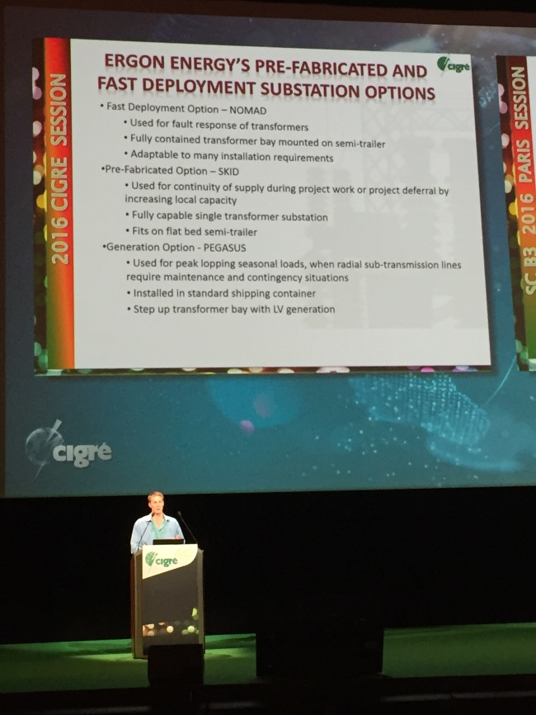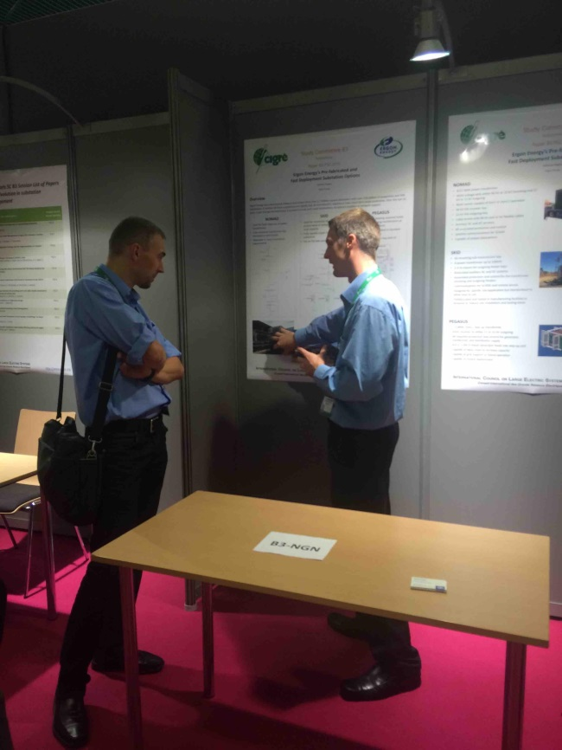

Figure : Matthew Ridgley Presenting at the B3 General Meeting and Poster Session

Observations and Learning Opportunities

I had the chance to attend a number of the events held throughout the week, including:

* Tutorial 5 by SC B3 on Air Insulated Substation Design for Server Climate Conditions. This was a great opportunity to see the differences in design philosophies in different regions faced by different climates. This was a great opportunity to see how money could be spent wisely over the life of an asset and some of the technical challenges involved.
* Sitting in on the SC B3 committee meeting to witness the more administrative side of CIGRE. Unfortunately, I had to leave half way through to attend the NGN / Young Members Forum.
* I attended the A2 and B3 Group Discussion Meetings to see all the contributions provided by a number of companies in these areas.
* I attended the Opening Ceremony on the Sunday and saw how many people there were, keen to help and advance the electricity industry for the benefit of society.
* I attended the Opening Panel: Global perspective of Distributed Generation impact on the bulk connected network. This contained nothing greatly new for me as Ergon as a distribution network has been focused on this area for some time. It was however to see how this change in mentality was affecting those that have mainly concentrated on transmission networks and markets and assumed a smaller importance of distribution assets.
* I spoke to a number of exhibitors to keep up to date with current developments and discuss some of the equipment Ergon Energy has. I saw exhibiters that produced substation test equipment as well as components in substations.

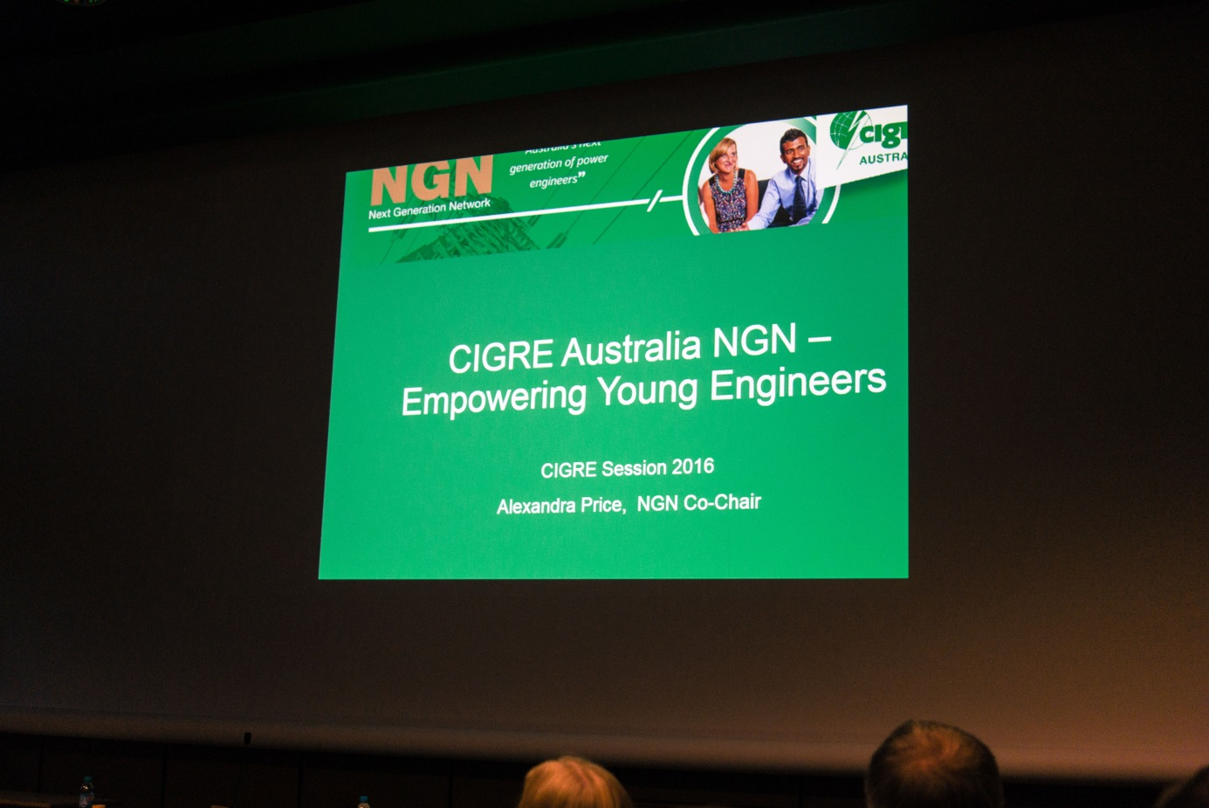

Figure : Alex Price's Presentation at the Young Members Forum

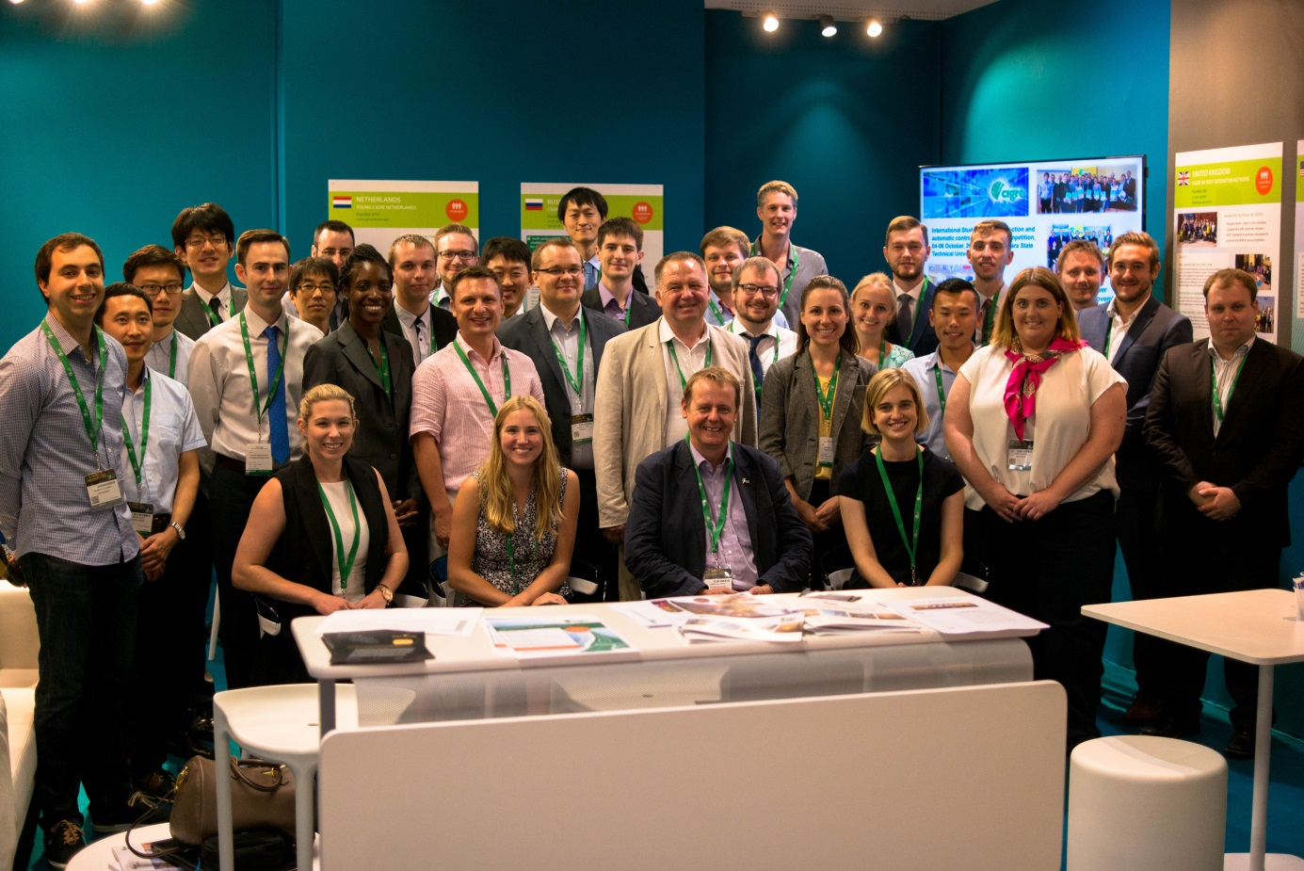

Figure : 2016 Young Member Group Photo

# Social Events

I had the pleasure of attending a number of social events where I could network with many other engineers who are interested in the industry. These provided the perfect opportunity to network with other industry professionals. Some of the events included:

* Welcome drinks on the Sunday afternoon following the opening ceremony
* The CIGRE Aus/NZ dinner which was definitely a highlight as it enabled me to meet with other engineers a bit closer to home and aware of the current issues in the local market. I also want to say a big thanks to Emma Rogers and Alex Price who ran the trivia night all by themselves so they didn’t need my help.
* The Young Members Social Night was held on the Wednesday. This was a great opportunity to discuss what is happening in other regions of the world as far as work practices, programs of works, business structures, etc. It was quite interesting to see how similar Ergon Energy was to some of the international counterparts.
* The CIGRE Official Cocktail Function on the Thursday night.

# Some Lessons from attending the Paris Sessions

I was constantly told that the CIGRE Paris Sessions were like nothing else, and they were right. Sometimes it was in a good way, some times, not so beneficial for me. These were some of the things I took away from the event itself.

* The CIGRE Paris Session is not a training event. It is a collaboration event built around trying to get answers for pressing questions in the industry (preferential subjects). You only get out what you put in.
* A large part of the Sessions is networking. This is an opportunity for an international crowd to come together at an event where the main theme is collaboration with each other. For those “seasoned” CIGRE members, this is an opportunity to strengthen long distance relationships. For those new to the event (e.g. me), it’s an opportunity to broaden your horizon from the limited view you get in Australia and begin building those international relationships. Be sure to do your best to build your network while you are there.
* Ensure you read the relevant submitted papers and special reports PRIOR to attending the sessions to get the most out of the Group Discussion Meetings. Try making a contribution if you can to contribute to the event.
* To make the most of the exhibitors, research who will be there before hand and arrange meetings with companies of interest with a set agenda. This will help avoid general sales discussions (unless that’s what you’re actually looking for). This will also allow the exhibitors to investigate who will be your local support back home and try getting an expert in the field available when you need them.

# Final Summary

I found the CIGRE Paris Sessions a great opportunity to expand my horizons and understanding of the electricity back home. It highlighted just how similar the industries are around the world which could likely be contributed to the work of CIGRE over the last century (well, almost century).

The Sessions are about contributing, collaborating and discussing topics. They are not a sit down and be told information type of event. To make the most out of the Paris Sessions, you must do your homework before you attend.

I was able to meet some marvellous people who are involved in CIGRE activities and have a real care and passion about their work. Many of these are based in Australia and New Zealand who I very much look forward to running into during either work or CIGRE activities.

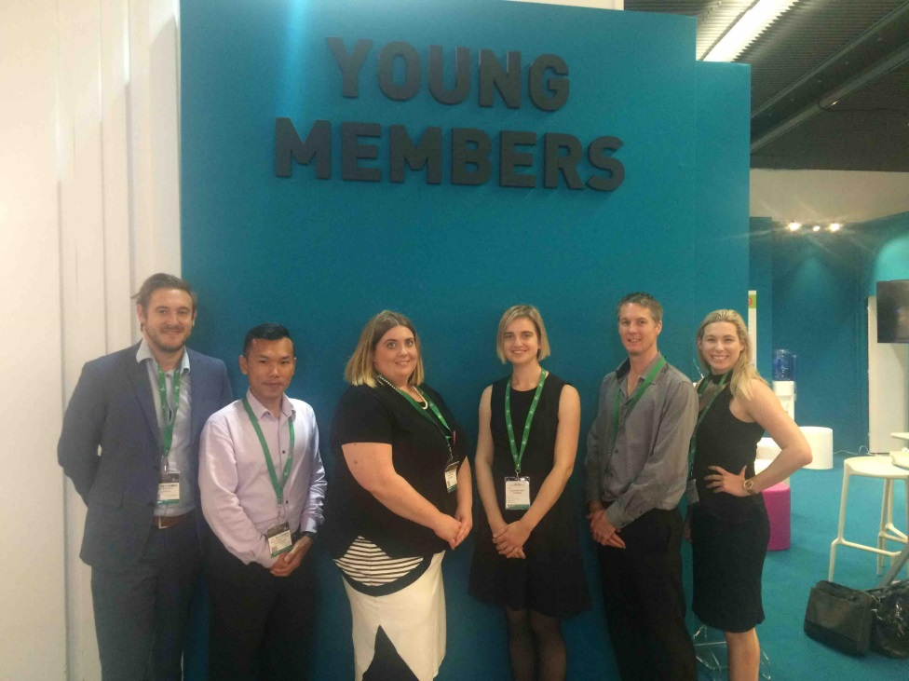

Figure 4: Australian NGN representatives (Left to Right): Stephen Sproul, Beer Opatsuwan, Emma Rogers, Alex Price, Matthew Ridgley, Tara-Lee Macarthur